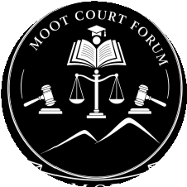
MOOT COURT FORUM (MCF)
Consent Form
2nd Edition National Inter-University ADR Moot Competition 2027
In connection with participation in this competition, the Moot Court Forum collects participants' names, contact details, student identification, and photographs and video footage recorded during the event. This data is used solely for competition administration, communication with participating institutions, official documentation, and the planning of future editions. All information is stored securely by the Moot Court Forum.
Scope of Consent

By signing below, the institution consents to the following on behalf of its participating students:
- Collection of registration and identification data
- Photographs and video recorded during the event
- Publication of competition results and names of winners
- Use of the above materials for MCF communications and future editions
Authorization

INSTITUTION NAME DATE

NAME OF SIGNATORY TITLE (DEAN / HOD)

SIGNATURE

